**Continuous Assessment for Laboratory / Assignment sessions**

Academic Year 2024-25

Name: _______________________________________________ SAP ID: _______________________

Course: High Performance Computing Laboratory Course Code: DJ19CEL802

Year: B. Tech. Sem: VIII Batch: _________

**Department: Computer Engineering**

|  |  |  |  |  |  |  |  |  |  |  |  |
| --- | --- | --- | --- | --- | --- | --- | --- | --- | --- | --- | --- |
| Performance Indicators  (Any no. of Indicators)  (Maximum 5 marks per indicator) | 1 | 2 | 3 | 4 | 5 | 6 | 7 |  Avg | A  1 | A  2 |  Avg |
| Course Outcome | **5** | **1** | **2** | **3** | **3** | **2** | **4** |  |  |  |  |
| 1. Knowledge (3) (Factual/Conceptual/Procedural/ Metacognitive) |  |  |  |  |  |  |  |  |  |  |  |
| 1. Describe (3) (Factual/Conceptual/Procedural/ Metacognitive) |  |  |  |  |  |  |  |  |  |  |  |
| 1. Demonstration (3)   (Factual/Conceptual/Procedural/ Metacognitive) |  |  |  |  |  |  |  |  |  |  |  |
| 1. Strategy (Analyse & / or Evaluate) (3)   (Factual/Conceptual/  Procedural/Metacognitive) |  |  |  |  |  |  |  |  |  |  |  |
| 1. Interpret/ Develop   (Factual/Conceptual/  Procedural/Metacognitive) | - | - | - | - | - | - | - |  |  |  |  |
| 1. Attitude towards learning (3)   (receiving, attending, responding, valuing, organizing, characterization by value) |  |  |  |  |  |  |  |  |  |  |  |
| 1. Non-verbal communication skills/ Behaviour or Behavioural skills   (motor skills, hand-eye coordination, gross body movements, finely coordinated body movements speech behaviours) | - | - | - | - | - | - | - | - | - | - | - |
| Total |  |  |  |  |  |  |  |  |  |  |  |
| Signature of the faculty member |  |  |  |  |  |  |  |  |  |  |  |

Outstanding (5), Excellent (4), Good (3), Fair (2), Needs Improvement (1)

|  |  |  |
| --- | --- | --- |
| Laboratory marks   Avg. = | Assignment marks   Avg. = | Total Term-work (25) = |
| Laboratory Scaled to (15) = | Assignment Scaled to (10) = | Sign of the Student: |

Signature of the Faculty member: Signature of Head of the Department

Name of the Faculty member: Date:

Bloom’s (Revised) Taxonomy

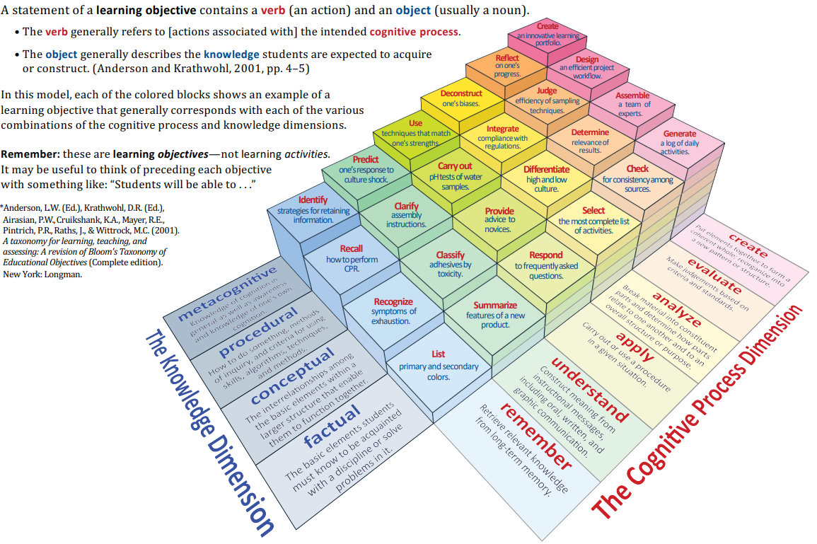

*Source:* \**Anderson, L.W. (Ed.), Krathwohl, D.R. (Ed.), Airasian, P.W., Cruikshank, K.A., Mayer, R.E., Pintrich, P.R., Raths, J., & Wittrock, M.C. (2001). A taxonomy for learning, teaching, and assessing: A revision of Bloom’s Taxonomy of Educational Objectives (Complete edition). New York: Longman.*

Course: High Performance Computing

|  |  |  |
| --- | --- | --- |
| Code | Course Outcome | Bloom’s Level |
| DJ19CEL802.1 | Comprehend fundamental concepts parallel processing approaches | Apply |
| DJ19CEL802.2 | Describe different parallel processing platforms involved in achieving High Performance Computing. | Understand |
| DJ19CEL802.3 | Discuss different design issues in parallel programming | Evaluate |
| DJ19CEL802.4 | Develop efficient and high-performance parallel programming | Apply |
| DJ19CEL802.5 | Learn parallel programming using message passing paradigm using open-source APIs and shared address space platforms. | Apply |